Saint Cecilia Church

Marriage Guidelines



“The matrimonial covenant, by which a man and a woman establish between themselves a partnership of the whole of life, is by its nature ordered toward the good of the spouses and the procreation and education of offspring; this covenant between baptized persons has been raised by Christ the Lord to the dignity of a sacrament.”
~ Catechism of the Catholic Church, No. 1601

Saint Cecilia Catholic Church

434 Norton Road

Columbus, Ohio 43228
Phone: 614-878-5353
Website: www.saintceciliachurch.org
Email: email@saintceciliachurch.org

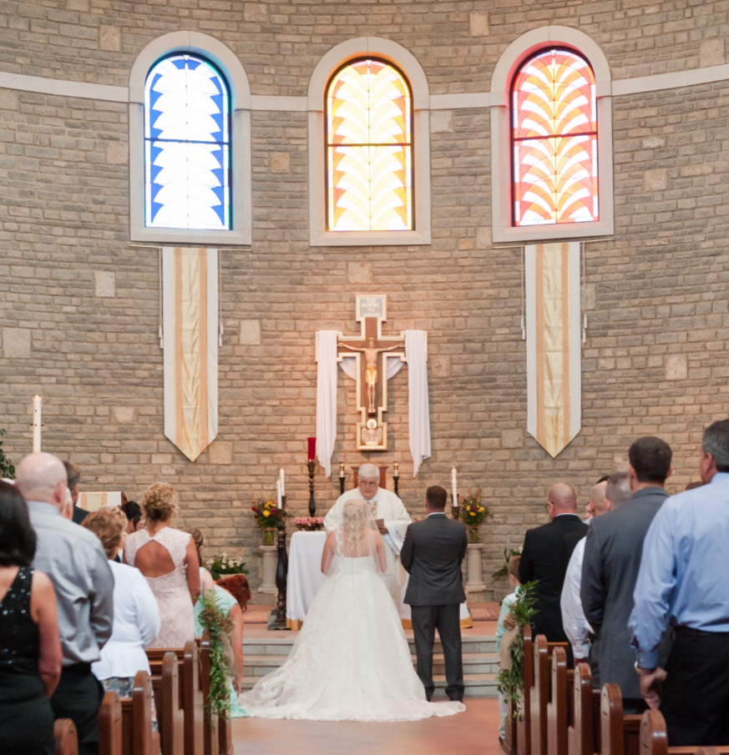

Dear Friends,

Congratulations! We welcome your inquiry about being married at Saint Cecilia Church. It is a privilege for us to assist you as you prepare to celebrate the Sacrament of Matrimony in our parish.

The Catholic Church regards marriage as very sacred — one of the seven sacraments of the Real Presence of Christ among us. Sacred Scripture compares marriage to the covenant relationship of God with his faithful people. Saint Paul writes that the union of husband and wife is a sign of the union of Christ and his Church.

In witnessing your marriage, our parish community wants to uphold and support you faithfully for the rest of your lives as you grow together in God who is Love. We undertake this ministry with you now as you begin preparing to live the Sacrament of Matrimony.

Because of the number of weddings that take place at Saint Cecilia Church, and to be fair to all couples, the guidelines in this document are strictly followed.

We look forward to serving you as we share our faith together.

Sincerely yours in Christ,

The Clergy and Staff of Saint Cecilia Church
Contents

WHO MAY BE MARRIED AT SAINT CECILIA?
- SETTING THE DATE AND TIME
- WHO MAY OFFICIATE AT YOUR WEDDING
- THE LITURGY OF MARRIAGE
- NECESSARY DOCUMENTS
- THE MARRIAGE PREPARATION PROCESS AT SAINT CECILIA
- ENVIRONMENT
- PHOTOGRAPHY
- CHOOSING READINGS, PRAYERS AND MUSIC
- CHOOSING MINISTERS FOR THE CELEBRATION
- CHOOSING YOUR WEDDING PARTY
- VIDEOTAPING
- PARISH WEDDING COORDINATOR
- FEES AND STIPENDS
- SUMMARY
- GUIDELINES FOR PHOTOGRAPHERS (Give to Photographer)
- RECEIPT OF MARRIAGE GUIDELINES (Give to Pastor)

WHO MAY BE MARRIED AT SAINT CECILIA?
Normally, practicing Catholics who are registered and active members of the parish or whose parents are registered and active members of the parish may be married at Saint Cecilia Church. In special circumstances and with the approval of the Pastor, Catholics from other parishes may be married here. One of the parties must be a Catholic.

- SETTING THE DATE AND TIME
It is important to meet with the parish priest/deacon shortly after you have decided to marry and before any other plans have been finalized. Diocesan regulations state a wedding cannot be scheduled for at least four months after your initial meeting with the priest/deacon. Because of the many weddings already scheduled at Saint Cecilia, the sooner you meet with the parish priest/deacon the better! Six months to a year in advance is not too early.

Weddings are available to be scheduled on most Saturdays during the year. Weddings are not scheduled during Lent or on Holy Days. Times for weddings are 11:00 a.m., 2:00 p.m., 2:30pm, and 7:00 p.m. At Saint Cecilia, only the Wedding Ceremony, not a Mass, may be celebrated at 7:00 p.m. on Saturday evenings. The rehearsal is usually scheduled at 6:00 p.m. the Friday before the ceremony. Rehearsals start promptly on time and last less than one hour. So that your wedding day runs smoothly, encourage your wedding party to be on time for the rehearsal.

- WHO MAY OFFICIATE AT YOUR WEDDING
Normally, the parish priest/deacon who has assisted in your preparation for marriage will officiate at your marriage ceremony. Priests/deacons who are your relatives or family friends are welcome to officiate at the wedding in one of two ways: he may con-celebrate the ceremony, or he may be the principal officiant, if it is arranged with the parish priest at Saint Cecilia. It is understood that the principal officiant conducts the marriage preparation process. Therefore, you will want to consult with priest/deacon who is a relative/friend very early in the preparation process before you make a decision.

If either bride or groom is not Catholic and would like to have the minister from his/her own church participate in the ceremony, they are welcome to invite him/her. This should be discussed with the parish priest/deacon early in the liturgy planning process so that suitable hospitality may be extended to the participating minister.


- THE LITURGY OF MARRIAGE
The Catholic Rite of Marriage celebrated at Saint Cecilia Church takes as its model the Sunday gathering of the community of faith in our parish with its full complement of ministers, music and the full and active participation of all present. Your wedding is a part of the faith life of our parish.

The Catholic Rite of Marriage, highlighted by the giving of consent, exchange of vows and the blessing and exchange of rings, best conveys the Church’s desire to witness your vows, to strengthen your fidelity to them, and to prayerfully support you in your life together. Accordingly, it is the policy not to allow the use or carrying out of rituals and symbols that are not described in the Catholic Rite of Marriage within the wedding liturgy proper. Specifically, this policy applies to the use of two different popular rituals: a ‘unity candle’, and a Marian devotion.

The lighting of candles is not part of the Catholic Rite of Marriage and therefore is not included in the wedding liturgy proper. A ‘unity candle’, rather, is more appropriately used at the reception. If you desire to carry out such an action at your reception, the parish can provide a suggested ritual for the lighting of a unity candle that helps to continue the celebration of your bond and highlight the symbols of unity carried out within the liturgy.

Also, although celebrating Marian devotions is certainly laudable and appropriate for newlywed couples, it is not part of the Catholic Rite of Marriage, and so is not to be included within the wedding liturgy proper. If the couple desires to celebrate Marian devotions, the parish can provide suggestions that would be appropriate after the recessional, at the rehearsal, or at the reception.

Because the bride and the groom are ministers of this sacrament, the Entrance Procession down the main aisle of the church will help to express this important reality. At Saint Cecilia, all members of the wedding party, the priest/deacon, bride and groom, witnesses, and other members of the wedding party make their way to the altar by the main aisle. If the bride and the groom choose, their parents may accompany them down the aisle as well.

The wedding ceremony is a sacred occasion and care must be taken to ensure that the garments chosen by the wedding party are appropriate in design and modest in cut so that they enhance the solemnity of the celebration.

For Catholics, the Church building is a symbol of God’s living presence among his people and the reality of our faith in the Incarnation. A prayerful reverence for this living presence in word and action must be the abiding concern of all the members of the wedding party when in this sacred space.

All plans for the ceremony are finalized with the priest/deacon before the rehearsal.

If a bride or groom has a particular devotion to Mary, this can be discussed with the Priest or Deacon.

- NECESSARY DOCUMENTS
The Baptismal Certificates of both the bride and groom, if applicable, are necessary to be married. It is the responsibility of the bride and groom to contact the Parish of Baptism to secure a copy dated within the last six months and have all notations listed. The certificate must be sent to Saint Cecilia Church, Attn: Marriage Records, 434 Norton Road, Columbus, OH 43228.

If either party has had a previous marriage, an annulment declaration from the Catholic Church must be presented before a date may be set.

The certificate of attendance at Pre-Cana or Engaged Encounter is also to be presented as part of your marriage file.

The marriage license is given to the priest/deacon the night of the rehearsal. You must apply for a marriage license in the county of your residence. There is a no waiting period before the license is valid. Marriage licenses in the State of Ohio are valid for sixty days from the date of application and are valid throughout the State of Ohio.

If either the bride or groom is not Catholic, the Catholic party will be asked to sign a document stating that he/she will remain a Catholic and share the Catholic faith with their children. This will be done in the presence of the Priest/Deacon.

THE MARRIAGE PREPARATION PROCESS AT SAINT CECILIA
The preparation process consists of two components: meetings with the parish priest/deacon and the Pre-Cana or Engaged Encounter programs.

After your initial meeting with the priest/deacon, you will have the opportunity to complete the FOCCUS survey. FOCCUS is a series of questions designed to facilitate discussion between the couple and the priest/deacon about topics related to married life. The couple’s responses to the survey will form the basis of additional sessions.

“Pre-Cana” and “Engaged Encounter” are programs of the Diocesan Marriage and Family Life Office to help couples who plan to marry explore various aspects of Christian married life. The dates and places of these workshops are available by calling the Family Life Office (241-2560) in Columbus or by consulting the parish.

There are fees for these programs.

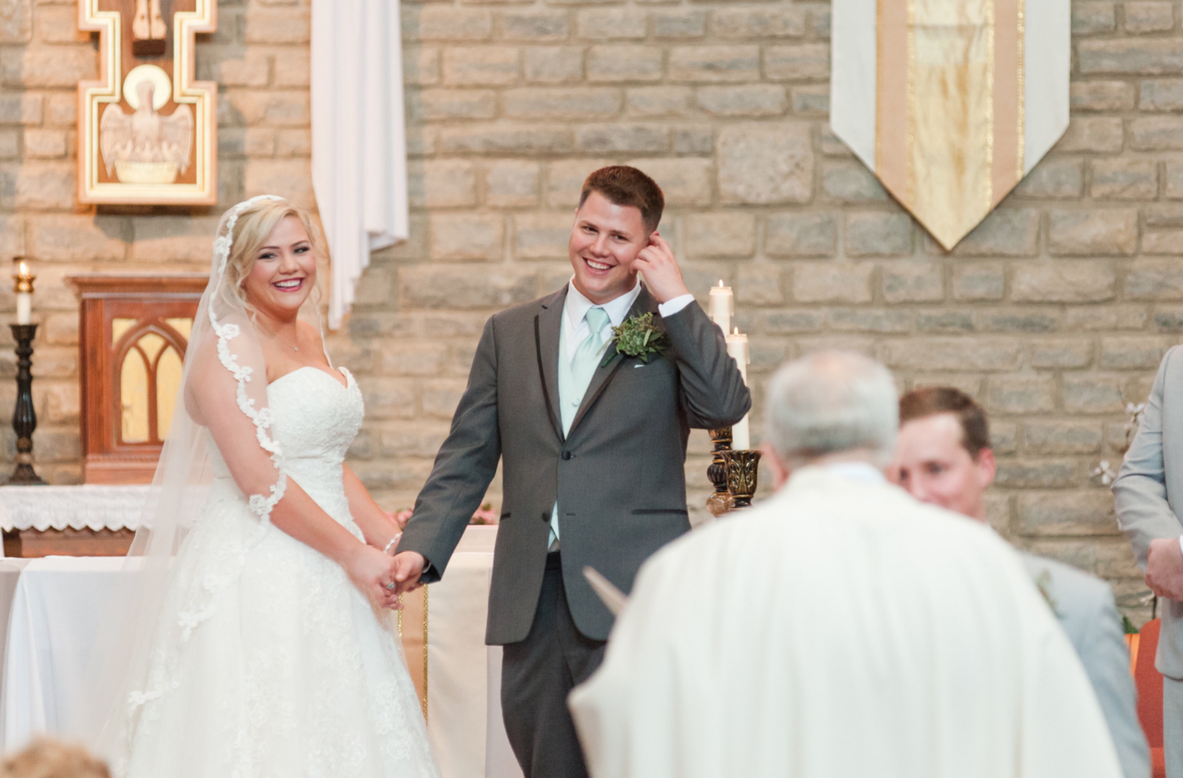

ENVIRONMENT
Very simple decorations are needed to enhance the beautiful liturgical space of Saint Cecilia Church. Normally, two flower arrangements placed in the sanctuary are sufficient decorations for a wedding. The flowers from your wedding are considered your gift to the parish and are kept in the Church for all weekend Masses. Seasonal decorations (e.g., Advent, Christmas, and Easter) cannot be removed for the wedding ceremony. No decorations are ever placed on the altar itself.

For safety reasons, the use of candelabra, lamps and floral displays with candles is prohibited. For aesthetics and safety, aisle runners, rice, birdseed, confetti, balloons and/or bubbles may not be used. Nothing is to be thrown, tossed or strewn inside or outside the church.

No adhesive material, pins, nails or tacks are to be used to attach anything to pews, doors or walls.

A receiving line and a guest book are appropriate at the reception and they are not permitted at the church.

Food, drink, and gum are not permitted in the church. No alcohol or any illegal substance is permitted at any time. Any sign of alcohol or illegal substance puts the celebration of the wedding in serious jeopardy.

Either the Saint Cecilia Room or Meeting Rooms A&B may be used for the bride and her attendants by contacting Jason in the Parish Office (614-878-5353). It is opened ninety (90) minutes prior to the time of the wedding ceremony. For security reasons, the wedding party is responsible for removing all belongings from the bride’s dressing room prior to the ceremony. Due to limited space, the groom and the groomsmen are to come to the Church dressed in their wedding attire, and may gather in the Priest’s Sacristy prior to the time of the ceremony.

All decorations and belongings must be taken out of the church immediately after the ceremony. Any items left in the church or the bride’s dressing room after the ceremony will be disposed of.

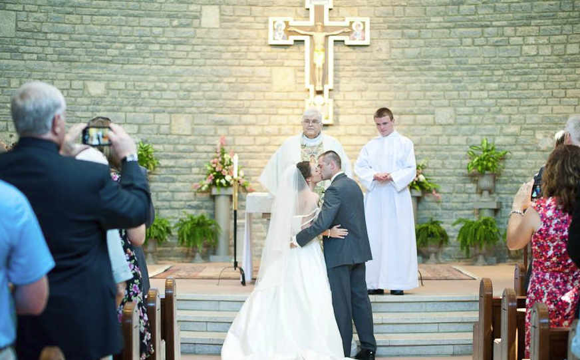

PHOTOGRAPHY
Photographers are welcome to take photographs before and during the ceremony at Saint Cecilia. If you wish to have posed photos taken after the ceremony, you must complete them by 4:00pm. In order to avoid distractions, the photographer is to check with the Wedding Coordinator at least thirty (30) minutes before the celebration to arrange for locations and final instructions.

The church is a sacred building and may not be used as a photo studio. The use of mounted lights and umbrellas is prohibited. Flash photography is limited to the procession of the wedding party prior to the ceremony and during the recessional. Flash photos during the wedding ceremony are prohibited. During the ceremony the photographer must be discreet and in no way obscure or interfere in the sacred ceremony being conducted. At no time whatsoever is the photographer to enter the sanctuary area of the church.

It is suggested that all posed photos be taken before the ceremony. Arrangements for the use of the parish Meeting Room A may be made through the Parish Office.

All of the picture taking must be completed by 4:00pm.

Wedding guests are asked to refrain from using personal cameras of all types during the ceremony.

- CHOOSING READINGS, PRAYERS AND MUSIC
The Rite of Marriage includes selected scriptural readings and prayers from which you may choose those most expressive of your understanding of marriage. You can find these selections in a special preparation booklet that you will receive from the priest/deacon.

After a date has been set with the parish, all couples are to contact the Director of Music to set up an appointment. The phone number to reach the Liturgical Music Director is 614-440-3555. The Director of Music from Saint Cecilia will meet with you to select the musical pieces for the wedding in accordance with the document “Diocesan Guidelines for Wedding Music.”

Because your wedding is a sacred ceremony performed in Church, only that music which is liturgically appropriate and sacred or classical in nature is permitted. Popular music or music from the theater is reserved for the wedding reception. The Director of Music will play the organ and arrange for and/or approve of additional musicians, cantors, or soloists. Taped and recorded music is never permitted. Only organists on staff at Saint Cecilia may play at weddings unless approved in advance by the Liturgical Music Director.

- CHOOSING MINISTERS FOR THE CELEBRATION
You may wish to select individuals to serve as Lectors, Extraordinary Ministers of the Eucharist, and gift bearers at the Liturgy. Only those who are duly trained and appointed by a Bishop may function as an Extra-Ordinary Minister of the Eucharist. Those persons that you choose to proclaim the readings at your ceremony should be not only practicing Christians, but also capable and comfortable proclaiming the Word of God. Decisions about these ministers are to be made when the Liturgy is planned with the priest/deacon.

- CHOOSING YOUR WEDDING PARTY
In choosing your witnesses, the best man and maid/matron of honor, the requirement is that they must be at the age of reason (i.e., over the age of 14 years).

Because of the unpredictability of young children, those children who participate as the ring-bearer or flower girl should be flexible and understanding of the nature of chaos leading up to and during the wedding ceremony, and be able to walk down the aisle when necessary.

- VIDEOTAPING
The priest may give permission for a family member, friend or professional to videotape the ceremony. The Wedding Coordinator must approve the position of the camera/cameras before the beginning of the ceremony.

- PARISH WEDDING COORDINATOR
The Parish Wedding Coordinator is here to oversee the liturgical needs on the day of the ceremony, and to see to it that the Liturgy runs smoothly. She/He is here to assist the priest/deacon and ensure the wedding party is in place and on time. In some instances, the Parish Wedding Coordinator may be asked to be present for the rehearsal or to conduct the rehearsal. Please see the “Fees and Stipends” section of these guidelines.



- FEES AND STIPENDS
An offering for the use of the church, usually $300.00, is asked of those who are not registered members of Saint Cecilia Church.

The fee for the service of the Parish Wedding Coordinator is $150.00. Check should be made directly to: Michelle Vent.

The fee for the parish organist is $200.00. The fee for parish cantors is $120.00. If other soloists and/or musicians are desired, additional fees will apply. The Music Director can assist you with these choices. Organist check should be made directly to: Dr. Caroline Salido-Barta. Check for Cantor should be made out to individual chosen by Music Director in advance.

The fees for the rental of the Parish Center are published under separate cover.

The stipend for the priest/deacon is a donation and in view of the time he has devoted to your preparation process. It is customary but not required to offer the Priest or Deacon $100.00 – $150.00 for his assistance. Check should be made directly to Priest or Deacon.

All fees for the use of the church, parish wedding coordinator and parish musicians are due in the Parish Office two (2) weeks prior to the ceremony. The Parish Office is open Monday-Friday, 9:00 a.m. to 4:00 p.m. Fees should be paid with separate checks to each of the above listed individuals.

TO SUM UP:

- Contact the priest to set date and time for wedding rehearsal.
- Contact your Church of Baptism to obtain updated Baptismal Certificate. Must be dated within 6 months of the wedding.
- FOCCUS survey is part of the Marriage Preparation and arranged at your meeting with the priest.
- Register for and attend Pre-Cana or Engaged Encounter by calling the Marriage and Family Life office at 241-2560.
- Contact Parish Office at 614-878-5353 to reserve room for the bride and attendants to dress.
- Doors are unlocked 90 minutes before the wedding for photographer, florist, dressing, etc.
- Contact the Liturgical Music Director to select music and/or musicians by calling 614-440-3555.
- Wedding Coordinator is here the day of the wedding (starting 90 minutes prior to wedding) to assist with the liturgical needs of the day. If extra time is required of him/her there is a $20.00 additional fee for each hour.
- Fees: $300.00 offering is asked for the use of the church for unregistered or unaffiliated members.

- $200.00 fee for Parish Organist (Check Made Out to: Dr. Caroline Salido-Barta)
- $150.00 fee for Wedding Coordinator (Check Made Out to: Michelle Vent)
- $120.00 fee for Cantor (Check made out to Cantor separately)
- $100.00–$150.00 stipend for priest (Check Made Out to Priest separately)

- Have all fees to Parish Office two (2) weeks prior to ceremony. Fees should be paid with separate checks to each of the above listed individuals.



SAINT CECILIA CHURCH
GUIDELINES FOR PHOTOGRAPHERS

We welcome photographers to the church for still photographs. For a pleasant experience we must ask that the following directives be followed.

The photographer should come to the sacristy at least one-half hour before the ceremony begins to check with the celebrant. The photographer is welcome to come to the church to begin taking pictures, ninety minutes (90) before the ceremony. All of the picture taking must be completed by 4:00pm.

The photographer should be as unobtrusive as possible during the procession. Photographers are not permitted to stop the procession to take pictures of wedding party. It is our firm belief that a wedding is a sacred ceremony – not a photographic production. Photographers should keep this in mind during the ceremony, and so remain as discreet as possible.

The photographer will never, at any time during the ceremony, be in the sanctuary proper. In Catholic terms, the sanctuary is the area including the steps and platform leading up to the altar. The steps of the sanctuary may be used to pose the wedding party for photos before and after the ceremony. At no time may anything be placed on the altar.

The use of mounted lights and umbrellas is prohibited. Flash photography is limited to the procession of the wedding party and the recessional. All equipment must be removed immediately after the wedding ceremony.

For posed pictures, photographers are asked to remember the sacred character of the church building. No bizarre or suggestive poses are allowed.

PLEASE GIVE THIS PAGE TO YOUR PHOTOGRAPHER WHEN YOU MAKE ARRANGEMENTS WITH THEM!

RECEIPT of MARRIAGE GUIDELINES
Saint Cecilia Church
434 Norton Road, Columbus, Ohio 43228
614-878-5353

PLEASE COMPLETE AND RETURN THIS FORM – ONCE IT IS RECEIVED YOUR MARRIAGE DATE WILL BE CONFIRMED. NOTE: IT IS NOT RESERVED UNTIL YOU RETURN THIS TO US! THANK YOU.

Bride’s Name: ______________________________________________________________________

Address: _________________________________________________________________________

Email: _____________________________________________________________________________

Phone (home): ______________________________ (work) _______________________________

Groom’s Name: _____________________________________________________________________

Address: _________________________________________________________________________

Email: _____________________________________________________________________________

Phone (home): ______________________________ (work) _______________________________

Date of Wedding Rehearsal: ____________________________ Time: _________________________

Date of Wedding: _____________________________________ Time: _________________________

Person who will officiate: _____________________________________________________________

Is this wedding with Mass? (Please circle) YES NO

Date all wedding fees are due (see guidelines) ___________________________________________

Is your reception scheduled for Saint Cecilia Parish Center? YES NO

Do you plan to remain parishioners after your wedding? YES NO

Address after wedding: _______________________________________________________________

We have read the parish guidelines for the celebration of the Sacrament of Marriage and agree to respect these guidelines:

Signature of Bride: ___________________________________________________________________

Signature of Groom:__________________________________________________________________

Date signed: ________________________________________________________________________

